FOR IMMEDIATE RELEASE

For more information contact:
Patterson Bach Communications
Nancy Glasgow, nancy@pat-bach.com, 407-375-2433
Kimbra Hennessy, kimbra@pat-bach.com, 407-415-6656

Three Additional MetroWest Communities
Celebrate Achieving Crime Free Certification

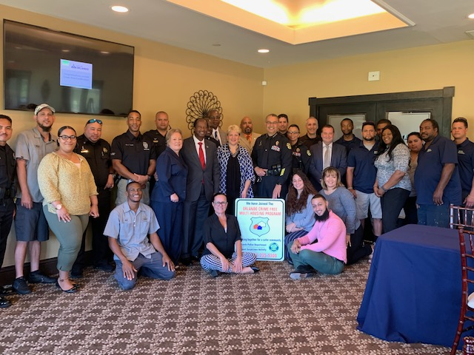

Attendees at the MetroWest Crime Free Certification Celebration April 24 include Chris Realin, OPD Multi-Housing Program Coordinator; the Vista Verde management team; MetroWest Public Safety and OPD officers; Nancy Stout, Central Park COA; City Commissioner Samuel Ings; Julie Sanchez, MetroWest Master Association General Manager; Shannon Bryson, MetroWest Public Safety Director; Orlando Police Chief Orlando Rolon; Rex Barrett, MetroWest Public Safety Manager; the Indigo West management team; and Chriss West of Goldelm.

ORLANDO, Fla. (April 25, 2019) – Three additional MetroWest communities have achieved Crime Free Certification and were celebrated at an event hosted by the MetroWest Master Association at MetroWest Golf Club on April 24.

“Crime Free Certification is a notable accomplishment that requires great dedication on the part of the owners and management team at each of these communities,” said Julie Sanchez, MetroWest Master Association General Manager.

The MetroWest communities that have received Crime Free Certification are:

- Goldelm at MetroWest
- Indigo West
- Vista Verde

MetroWest now boasts 11 Crime Free Certified communities. Eight other MetroWest communities received Crime Free Certification in 2018. They are:

- Alvista MetroWest
- Amara at MetroWest
- Central Park A MetroWest Condominium Association
- Horizons at Stonebridge Place
- The Residences at Veranda Park
- Stonebridge Reserves
- The Summit
- Vistas at Stonebridge Place

Attaining Crime Free Certification is a three-phase process, requiring an eight-hour certification class, inspections by both the Orlando Police Department and Orlando Utilities Commission, and fulfilling Crime Prevention Through Environmental Design (CPTED) requirements.

Several other MetroWest communities also are working toward Crime Free Certification.

About MetroWest
MetroWest, developed in 1986, is one of Orlando's first master-planned communities and features award-winning landscaping and MetroWest Golf Club, as well as high-performing public schools, the Valencia College campus and convenient access to both I-4 and 408 from the west side of Orlando. MetroWest offers a community lifestyle with neighborhood businesses and outdoor recreation options. The diverse community is complemented by a range of living options, from single-family homes of all sizes to apartments and condominiums. For more information, please visit www.MetroWestCommunity.com.

